THE PENNSYLVANIA STATE UNIVERSITY

SCHREYER HONORS COLLEGE

DEPARTMENT OF STATISTICS

PREDICTING THE OUTCOME OF THE FINAL SIXTEEN TEAMS IN COLLEGE BASKETBALL USING TIME SERIES ANALYSIS AND MARKOV CHAINS

CHRISTOPER KENNETH MILLER

SPRING 2023

A thesis

submitted in partial fulfillment

of the requirements

for baccalaureate degrees

in Statistics and Mathematics

with honors in Statistics

Reviewed and approved* by the following:

Andrew Wiesner

Associate Teaching Professor of Statistics

Thesis Supervisor

David R. Hunter

Professor of Statistics

Honors Adviser

* Electronic approvals are on file.

ABSTRACT

The cumulating tournament for collegiate level basketball brings together a field of sixty-four teams to crown a champion, this is called March Madness. There a many different approaches to ranking and predicting the outcome of the games within the tournament. In this paper a new approach is taken using time-series analysis approach to capture the effect of trends throughout the season. The underlying time-series model will be based on a team’s efficiency rating, or put otherwise, a team’s ability to score and defend well against other teams, adjusting for relative strength. Two types of time-series models are considered, a dynamic auto-regressive integrated moving average (ARIMA) model that is fit uniquely to every team, and a dynamic exponential smoothing (ETS) model that is also fit uniquely to every team. These models are used on nine different college basketball seasons from 2011 to 2019, using a probability Markov-Chain approach to determine winning probabilities to predict only the first two rounds of the March Madness tournament. Over the nine years, either the ARIMA or ETS method predicted the same or more correct games over the first two rounds when compared to a baseline method which predicts the favorite seed for every matchup. The analysis also looks at the effectiveness of predicting upsets, the ARIMA method predicts upsets correct 49.3% of the time while the ETS method sits at 59.3%. It is recommended that this type of modeling for March Madness predictions would be best used to quantify trending teams. The ETS model slightly outperforms the ARIMA model and both models are most effective when trying to determine closely seeded matchups.

TABLE OF CONTENTS

LIST OF FIGURES iii

LIST OF TABLES iv

ACKNOWLEDGEMENTS v

Chapter 1 Introduction 1

Motivation and Overview 3

Chapter 2 Efficiency 4

Chapter 3 Data Considerations and Setup 6

Chapter 4 Time-Series Model 7

ARIMA 7

ETS 13

Chapter 5 Markov Chain as Probability Model 15

Chapter 6 Analysis of Results 18

Upsets 20

2023 Results 22

Chapter 7 Limitations and Conclusions 22

Limitations 22

Conclusions 25

Appendix A R Code 27

BIBLIOGRAPHY 28

ACADEMIC VITA 29

LIST OF FIGURES

Figure 1 – March Madness Region Example 10

Figure 2 – Average Prediction Probability Curve 13

LIST OF TABLES

Table 1 – Example of Different Methods Probabilies in East 2011 Region 12

Table 2 – Overall Percent Games Correct by Year for Each Method and Round 14

Table 3– Overall Games Correct by Year for Each Method and Round 14

Table 4 – Upset Graphic 1 16

Table 5 Percent of Predicted Upsets Correct 16

ACKNOWLEDGEMENTS

# Introduction

National Collegiate Athletic Association (NCAA) Division I men’s basketball is a widely publicized sport in the United States, and like many other sports, the use of statistics to make some informed decision has become relevant for the league, analysts, coaches, and even the casual fan. The validity and usefulness of certain statistically backed reasoning can be questioned and explored but it is undeniable that number-backed decisions provide concreteness to any given conclusion. In the eyes of analysis, this sport provides an extra level of difficulty due to the collegiate aspect. In a traditional professional league, you can note some small material differences between teams, for example, payroll size, organization location, owner investment strategies, but overall, you can do analysis with the assumption that the professional teams are all on the same level of fairness. When we look at the collegiate level there are two main levels of unfairness that we must consider when looking to do any sort of statistical analysis, access to funds and recruiting level.

It is known that the NCAA basketball tournament, also known as March Madness, the final tournament of the NCAA season is regarded as the pinnacle of sports. It is a single elimination tournament that decides the overall champion of college basketball each year. The tournament is set up such that out of the 32 Division I conferences, the champion of each is guaranteed a spot in the tournament, then 36 other teams that impressed the NCAA committee(1). This guarantee’s representation of every conference, and rewards teams that play tougher conferences, which goes back to the unfairness factor in this sport. When the field of 68 teams is set, the NCAA committee then decides seeding, such that the best teams would play the worst teams on a path to the championship, this rewards the teams that did the best in the regular season. This seeding decision by the NCAA is at least in part, statistically based, and by creating an order of teams, the NCAA is essentially making their own prediction of what teams they think are better than others(1). If the NCAA’s ranking was completely true, then the lower seed would always win with the top ranked number one seed winning the whole tournament. We know this is not true, for example, since 1984 when the tournament expanded to 68 teams the seed 5 teams only have a 63% win rate in the initial matchup against the seed 12 teams(2). Much of this randomness in predicting relative team performance has to do with the complexity of valuing how much the aforementioned unfairness contributed to the team’s performance.

This complexity has led to many other analyst’s having different ideas than the NCAA, other ranking systems focus on different metrics and methods like efficiency and relative performance. Some years these methods perform better than others, but no method is correct, but rather other methods provide a reasonable prediction performance and more importantly a unique way to explore the relative strength of the teams in the tournament. This brings about the objective of this research paper, to provide a new unique way to look at March Madness teams’ relative strength while also having a reasonable prediction performance.

## Motivation and Overview

One thing you’ll commonly hear when it comes to March Madness predictions is, what teams are hot? This prompt usually explores what teams are trending up recently and what teams are trending down and how that all plays into overall predictions. If we look at popular prediction methods, we can see how they take this prompt into consideration.

The industry standard prediction, KenPom, is an adjusted efficiency margin rating that uses some adjusted offense and defense efficiency (this will be discussed in more detail later), and uses an additive model to create efficiencies for each game throughout the season then averages the two metrics to rank the teams(3). Many of the other popular rankings will have the same general idea, calculate a rating for a team's performance in any given game weighted by SOS, venue advantage, etc., then take the average rating to rank the teams. Most of these methodologies tackle recency in a similar way, KenPom states , “The adjusted game efficiencies are then averaged (with more weighting to recent games)”(4), and RoundTable ratings states, “More recent games are weighted heavier than games from the early season” (5). Sagarin comes the closest to focusing purely on teams’ trends by stating, “The RECENT, is score-based and weights RECENT play more heavily than earlier games. Its effect will become more pronounced the longer a season goes if a given team happens to have an upward or downward trend.”(6) It is unclear how Sagarin decides what a trend is and how much more pronounced effect is. It is also important to note that Sagarin uses this factor as one of three factors in his overall rankings.

The methodology used in this paper will completely focus on a time-based approach to the prediction of overall teams’ ratings at the time of the start of the final tournament. An adjusted offensive and defensive efficiency will be calculated for each team and game and those metrics will be combined for an overall rating for each team and game. These game efficiencies will be used in a simple moving average model and an automatically detected time-series model to predict ranking values for the field of 68 teams in the tournament. Then a Markovian approach will be taken to calculate the probabilities for the team's success in the first two rounds in the March Madness tournament.

# Efficiency

The first component to understanding the calculations behind the performance rating we will give to a team for each game to be used in the time-series analysis is adjusted efficiency. For efficiency calculations we will not stray away from the industry standard. This is because exploring and testing new efficiency calculations is not in the scope of this paper and is unreasonable given most efficiency calculations don’t stray too far from each other. For this data we will use data from Bart Torvik and his efficiency calculations. For each game the winner and loser are assigned an offensive and defensive efficiency. These efficiencies are calculated using points scored/allowed per 100 possessions. Possessions are defined as $PPP=\left(FGA-OR\right)+TO+(Y*FTA)$. (https://kenpom.com/blog/the-possession/) The first component is a shot by the offense that is discounted by continued possessions, which is denoted as offensive rebounds. The second component is an offensive turnover and the last is a random number from 0 to 1 times free throws attempted because it is not known how much a free throw should count as a possession. After calculating the PPP for the offense and defense for a team (the opposing teams PPP for offense will be the other teams PPP for defense and vice versa), we can adjust these PPP’s to get our adjusted offensive and defensive efficiencies.

The PPP’s are then adjusted by opposing team strength and venue location. The formula for this adjustment goes as follows: (http://adamcwisports.blogspot.com/p/every-possession-counts.html)

$$Game Adj. OE=PPPo/(\frac{Opp. Adj. Average DE*Venue Factor}{League Average PPP})$$

$$Game Adj. DE=PPPd/(\frac{Opp. Adj. Average OE*Venue Factor}{League Average PPP})$$

The venue factor is 1.4% so if the team is home the factor is equal to 98.6% and is 101.4% on the road. The calculation boils down to a performance metric to see how well a team scores/defends comparative to the relative strength of their opponent. It is important to note that a higher game adjusted OE is related to a strong offensive performance and a lower game adjusted DE is related to a strong defensive performance.

At this step, the method used in this paper will diverge from most predictive methods. Here, most predictive methods will use some algorithm combined with outside factors to create predictive ranks. For example, KenPom popularized using the Bill James’ pythagorean expectation method for calculating actual rank. (<https://arxiv.org/abs/math/0509698>) I will calculate a game performance metric for any given team as:

$$Game Adj. OE- Game Adj. DE$$

The predictiveness in my method will be taking this game performance metric and applying it to time-series forecasting methods. The reasoning for not using a more complex method to calculate the game performance metric is because I did not want to have focus on the background data going into the time-series model. If a more complex method was used like Bill James’ pythagorean expectation method, then the interpretability of the effectiveness of the time-series model could be brought into question as the pythagorean expectation method is predictive in its own nature.

# Data Considerations and Setup

It is important to note that this method, like the other popular methods, is predictive and not retrodictive. When carrying out this methodology my rankings are supposed to predict how well the teams will do going forward, it is not a model to see what factors best explain results that have already happened, a better explanation of this can be found at (7). That said, the data range used for the time series analysis is the regular season games for any given team. Only regular season games that are in the year of the predicted tournament are considered. This is because year over year college programs can experience a lot of turnover with transfers, graduates, and NBA draft declarations. It should be noted that in a sense that the previous season does have a small implication on a couple of the first games because there needs to be a base ranking set to calculate the first games efficiency ranking, and the base ranking is in part based on preseason rankings. When saying that just regular season games are used that also means that conference games are not included in the data. This is because it can be argued that teams don’t have similar amount of games when some teams play more conference tournament games than others, also any one-bid conference (a conference in which only the champion makes the tournament) will automatically have higher predictions than intended just because they succeeded in the tournament format.

The regular season data is collected from Bart Torvik’s T-Rank site which allows me to go back into previous seasons and collect season data at a specific date. The tournament seeding data is collected from (kaggle), combining these two datasets to cover the seasons from 2011-2019. This allows for predictions for 9 tournaments, and it is important to note that the format over this time period is consistent year over year, in 2011 the NCAA committee added the First Four play-in games, but we will not be predicting those games as most brackets do not count those games. From the regular season data, we will use the offensive efficiency and defensive efficiency statistics that were discussed in the previous section. We can see that the overall data counts 47460 regular season games, 603 tourney games, and 352 unique teams over the 9 seasons. (Figure)

# Time-Series Model

## ARIMA

Given a set of adjusted offensive efficiencies and a set of adjusted defensive efficiencies and the combination of both we can now apply a time-series analysis on the season data for the teams. The main problem is that we are dealing with many different teams in multiple years and the main goal is to fit a time-series that is right for all each one individually in order to forecast future values. This can be done using the auto.arima function in R in the forecast package.

The function uses an algorithm called the Hyndman-Khandakar algorithm which determines the best ARIMA (Autoregressive Integrated Moving Average) model for a given team each year. We will consider three parameters for this model, p, which is the degree of the Autoregressive term, d which is the amount of times the time-series data has to be differenced in order to create stationary data, and q, which is the degree of the Moving Average term. For the sake of our data there will be an assumption made that there is no seasonal component to our data because we are only modeling within a singular year. The formula for this model can turn out to be:

$$ϕ\left(B\right)\left(1-B^{d}\right)y_{t}=c+θ\left(B\right)ε_{t}$$

Where B is a backshift operator (https://otexts.com/fpp2/backshift.html) and the phi and theta functions of B correspond to a degree polynomial of the order p and q, respectively. The $ε_{t}$ is a white noise process with mean zero and variance $σ^{2}$. If $c=0$ then there is an implied order of differencing of d.

This algorithm works by first finding the order of differencing needed in the time-series model. Approaches before have suggested minimizing AIC from different combinations of models, but this can lead to over-differencing, instead the algorithm uses successive KPSS unit-root tests to determine the differencing coefficient. Then p and q are found using a step-wise selection minimizes the AIC. This is important in relation to working with team data as a time series. Many team’s data could already have a stabilized mean throughout the season, for example a team that has never seemed to go on a stretch of good or bad games, compared to a team that is streakier and would have not have a stabilized mean. The algorithm will take both of those scenarios into account and determine which is appropriate according to the team’s trends. The last thing to note is that for this algorithm to work as intended there is assumption of homoscedasticity that must be made about the time-series data beforehand. With team game data we will find that there are not enough games in a season to identify a trend in variance that would violate the homoscedasticity assumption. This is helpful in the fact that the ARIMA model can be used with this data, but it also begins to uncover a limitation with the time-series model and this team data in the fact that ARIMA models tend to work stronger with more data points. Here is an example of Penn State in 2011 and how they were fit to an ARIMA model. First, we can look at the time-series graph with Penn State’s performance metric on the y-axis and the games in chronological order on the x-axis.

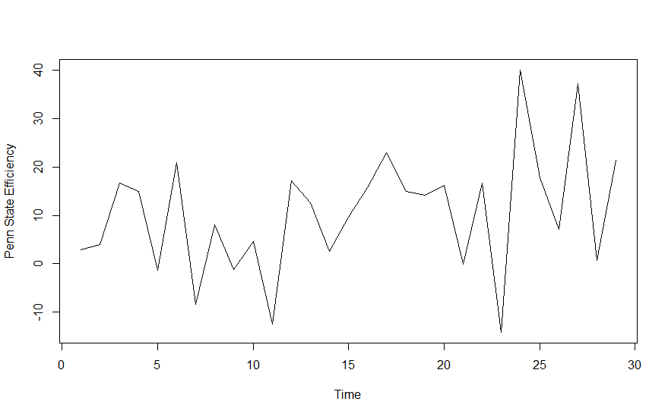

We can see that there is some high variability over the year for Penn State, therefore I would consider differencing the data to make it non-stationary before fitting the time-series model.

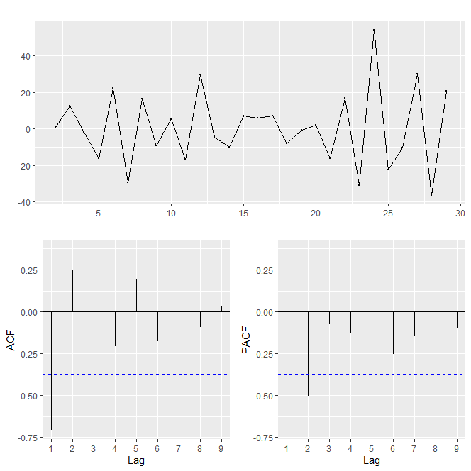

Now we can see that from differencing the time-series data we have stationary data. If the model was being fit manually, the ACF and PACF plots would be consider to find the p and q parameters of the ARIMA model. We can see that there is no tail off in the ACF and PACF plots, so models with p and q parameters greater than one should be considered, and looking at the plots specifically, models with a moving average component of 1 and an autoregressive component of 1 and 2. Now, if the auto.arima function is used it considers multiple possible combinations of these models and fits the model with the lowest AICc. For Penn State in 2011 this turns out to be a model of parameter, p = 1 and q = 1, with one differencing of the time-series data, so ARIMA(1,1,1). The fitted and forecasted points overlayed on the original time-series graph looks as follows, the red line being the model and the black line being the original.

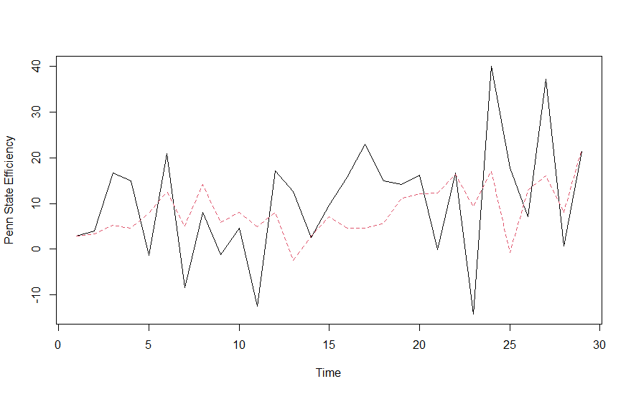

## ETS

We will also explore a second method for forecasting the performance values of the tournament teams. For this method we will model the time-series data and apply an automatic exponential smoothing method to the data. This is a function in the same R “forecast” package, called ETS. In the automatic ARIMA method we assume of homoscedasticity that we allow to be passed by the nature of the data.

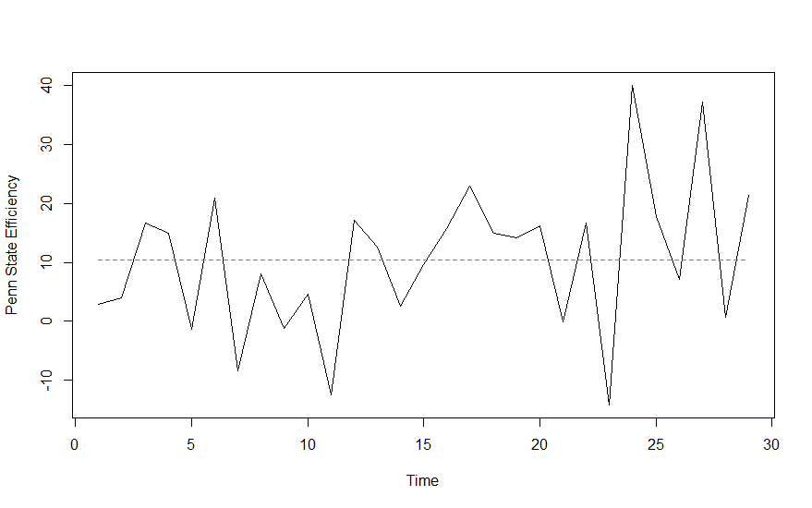

# Markov Chain as Probability Model

For every year we have a set of numbers defining the teams to participate in the final NCAA tournament. As stated in the previous section it was stated how we are using a time-series analysis to populate these set of numbers, but we can see that the following Markov Chain method to get expected probabilities of teams making it to the first and second rounds can be applied to any set of numbers that are defining the teams as long as those set of numbers are positive. This idea of a probabilistic model to create expected results will loosely follow the work of (SCHWERTMAN)

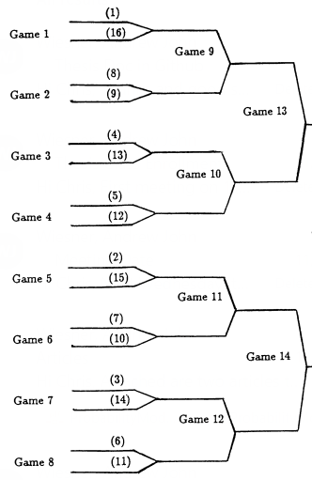There are 64 teams in the tournament and these teams are split into four different regions. For any given year we are predicting the last four remaining teams in each region therefore overall predicting 16 teams. This stochastic method takes the set of any pair of four connected teams in any given region, for example, seeds (1,16,8,9) or (2,15,7,10), and finds the probability of making past the first round and probability of making it past the second round.

Figure – March Madness Region Example

We can define $P_{k}\left(i,j\right)$ as the probability of a given team with seed $i$ beating seed $j$ in the $k^{th}$ game of the region. Then we can define $P\left(i,j\right)=\frac{u\left(i\right)}{u\left(i\right)+u\left(j\right)}$ where, $i≠j$ and,

$u\left(x\right)=Performance Metric of x^{th} seed in region$ and $u\left(x\right)>0$

$$∴0<P\left(i,j\right)<1$$

We can now see that if for example, we wanted the probability that the third seed wins their first game, we can find it using $P_{7}\left(3,14\right)=P\left(3,14\right)=\frac{u\left(3\right)}{u\left(3\right)+u\left(14\right)}$. A Markov Chain matrix can now populated with $P\left(i,j\right)$ as the cells and the rows of this matrix will be seeds one through sixteen and the columns will be the same. From the matrix and the bracket we can see that if, for example, now we wanted the probability that the third seed made it to sweet sixteen (second round), we can find it using,

$P_{12}\left(3,j\right)={[P}_{7}\left(3,14\right)*P_{8}\left(6,11\right)*P\left(3,6\right)]+[P_{7}\left(3,14\right)*P_{8}\left(11,6\right)*P\left(3,11\right)]$

As an example, we will take the East region in the year 2011 and populate a table of the probabilities for each team to make it to round one and sweet sixteen using the three methods define $u(x)$, the baseline seed method, ARIMA method, and exponential smoothing method.

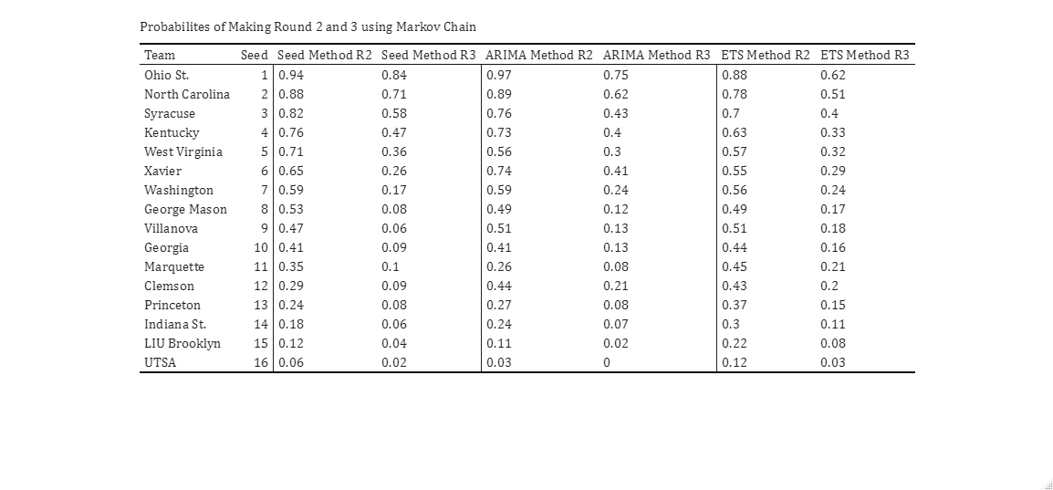

Table – Example of Different Methods Probabilies in East 2011 Region

We can see the differences between the three methods in this table, it is important to note that for any region the seed method will always have the same probabilities because the nature of $u(x)$ for that method is not dependent on the actual characteristics of the team. For this region and this year, we can see that the ARIMA method only predicts one upset, although it does predict a close first round game between 5 seed West Virginia and 12 seed Clemson. The ETS method predicts the same one upset as the ARIMA method but is much more favorable to the performance of the lower seeds in that region. This dynamic will change depending on the region and the year and this can be explored along with the performance of each method’s ability to predict what happened.

# Analysis of Results

With the methods set and Markov-chain creating winning probabilities, the code now runs a loop for every tournament team in the nine years of study to simulate predictions for the first two rounds of each of those years’ tournaments. First, we can look at the differences between the methods over the nine years.

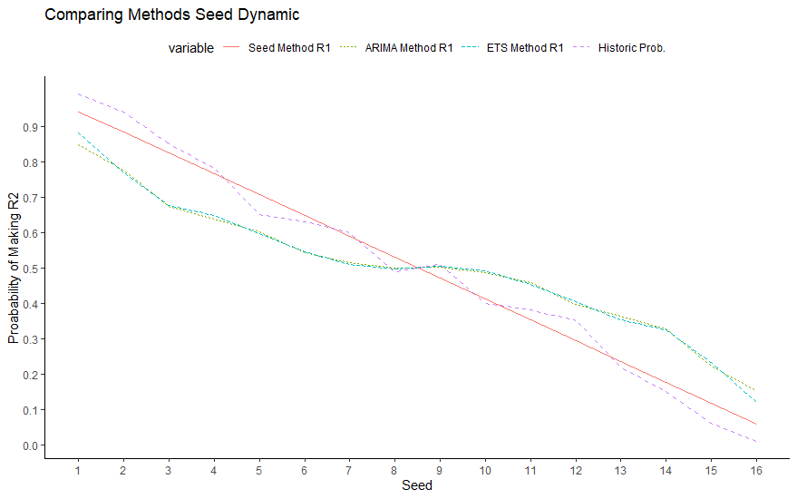

Figure – Average Prediction Probability Curve

Overall, we can see that both the ARIMA and ETS methods act similarly in average when it comes to deciding the relative strengths of teams and we can see that both of these methods give much more relative strength to lower seeds than the seed method, as expected. If you were to graph the historical probabilities for first round winning percentages for each of these seeds, you might see something like the ARIMA and ETS curves for the seeds 3 through 14, but something more like the seed method for the high and low ends of the seeds. This is important to note because it provides some evidence to the fact that the ARIMA and ETS methods are more accurately reflecting what could happen in a NCAA tournament, but also there can be some worry that the method could be overvaluing lower seeds.

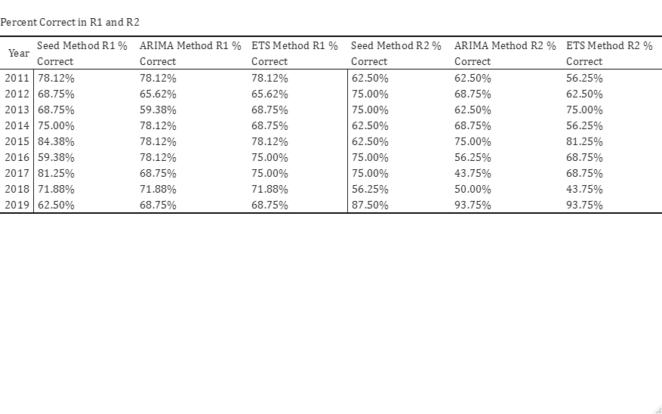

Table 2 – Overall Percent Games Correct by Year for Each Method and Round

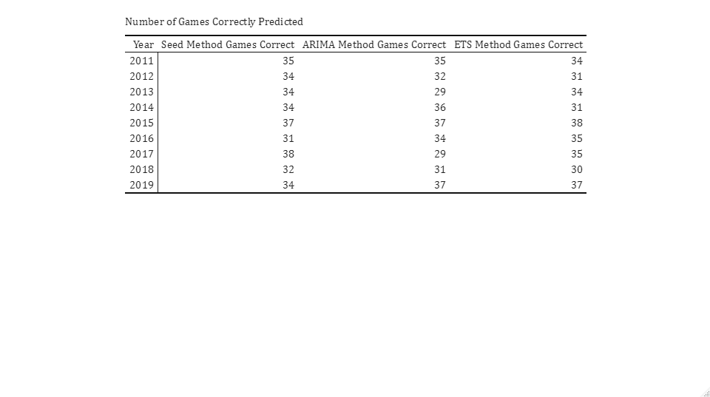

Table 3– Overall Games Correct by Year for Each Method and Round

Here are the tables that show the effectiveness of the three methods compared to each other in each year. In only three of the years, 2012, 2017, and 2018, is picking the better seed the best option. Between the ARIMA method and ETS method, they tend to perform slightly different every year, with ARIMA predicting more games correct in four years, ETS method predicting more in four years, and the methods tying in 2019. Between the ARIMA and the ETS method, the ETS method holds a slight advantage, predicting 0.556 more games correctly. It seems to be that the ARIMA method is less consistent than the ETS method with a standard deviation of 3.20 compared to 2.76. The is consistent with the two time-series analysis methods as the smoothing method is going to give a more conservative of team’s performance tending towards a team’s overall mean performance whereas the ARIMA method can provide a larger range of predictions depending on the model fit. The seed method outperforms the ARIMA and ETS methods on average by 0.11200 and 0.00071 games respectively in round one, and by 0.889 and 0.444 games in round two. This can be indicative of the fact that the time-series methods have no regard to the underlying assumption of strength by seed position and might predict more upsets than needed. This could also be seen from figure 2 that the time-series methods were overpredicting the value of seeds above 13, as we can see from the difference between the estimated win probabilities for the time-series methods and the historical win probabilities. If we assume that we will lean heavily towards favorites when the difference in seeding is large, we then can also look at the predictiveness on just the closer matchups, or any matchup where the difference between the higher seed and lower seed is less than 7.

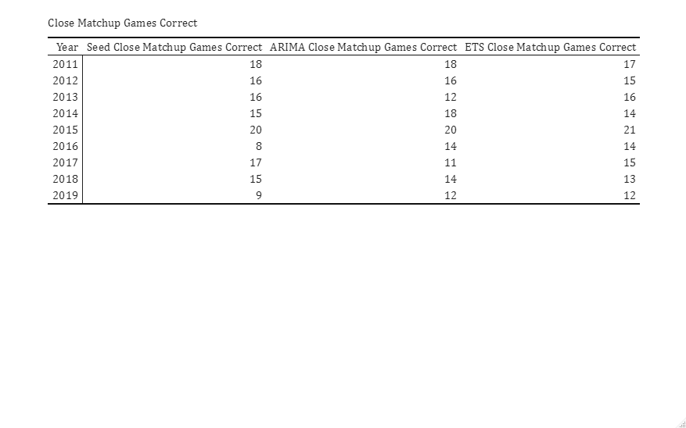

Table 4 – Close Matchups Comparison

We can see here that the difference of predictiveness between baseline seed method and the time-series methods is much tighter when looking at these close matchups only. Overall, the seed method predicts 14.89 close matchup games correct, while the ARIMA and ETS method predict an average of 15 and 15.22 close matchup games correct. This provides some evidence that the time-series methods are more effective at predictions with closer seeded matchups compared to farther seeded matchups.

## Upsets

Though, upsets are one thing that are hard to predict in a March Madness tournament and any method that has insight into an upset can be valuable, the seed method does not have the ability to predict these upsets, but we can see how effective the time-series methods are in predicting these matchups.

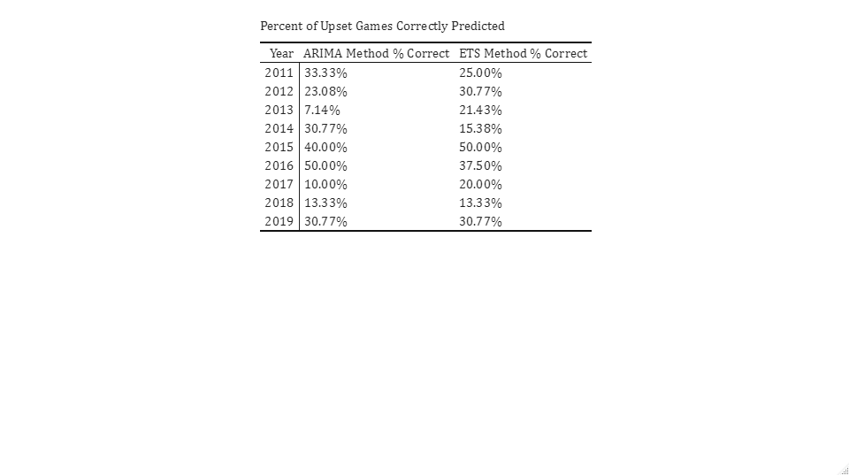

Table 5 – Percent of Upsets Predicted

On average the ARIMA methods 26.49% of all upsets in the first two rounds of the March Madness tournament over these nine years, while the ETS method predicted 27.13% of upsets. This numbers can be useful, but more importantly we would want to know the number of upsets correctly guessed divided by the total amount of predicted upsets by the method. This would be more useful because if you were deciding using this model, it could be good to know how accurate the upset picks of the model are.

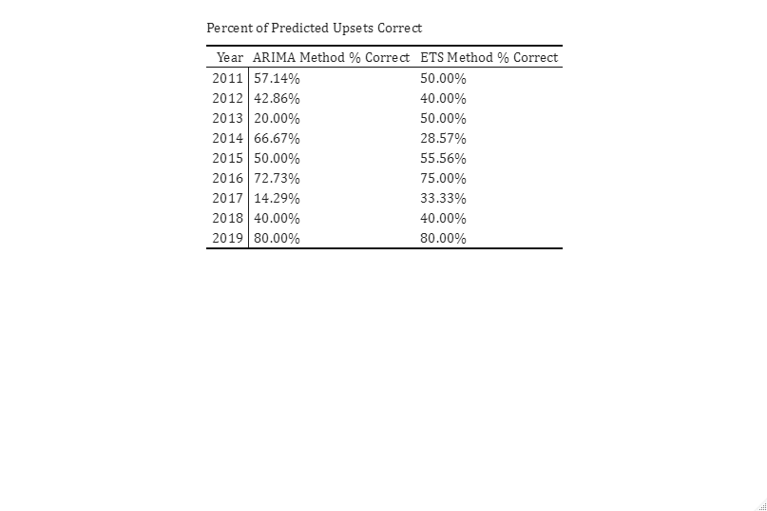

Table 6 – Accuracy of Predicted Upsets

Overall, the ARIMA method is correct about its upsets 49.3% of the time while the ETS method is correct 59.3% of the time. The standard deviation of the ARIMA method is much higher at 0.23 while the ETS is at 0.18. In certain situations, this proves that the methods are helpful in predicting upsets, and in others it is not. For example, if we are looking at a seed 8 vs seed 9 matchup, the ~50% accuracy might not be as helpful because 8 vs. 9 already is a very close matchup. Now, if the model predicts an upset for a 6 vs. 11 or 5 vs. 12, then the model’s accuracy becomes more useful. Without any prior knowledge it is very difficult to predict an upset of that nature, but if the model says there is a 50% chance that this upset happens then you might become much more inclined to at least do more research into that matchup.

## 2023 Results

# Limitations and Conclusions

## Limitations

As a reiteration of a commonly made point, the statistical methods used in this paper are for predictive purposes and it is not created in the typical way by creating a one-size-fit all model that is trained on some data and tested on others. Each team in all the nine years of my study are their own training data as the time-series model I fit for a team depends only on their experience. The nature of using a flexible time-series model is important because we know that a given teams performance never acts the same compared to another team.

Using the predictions from the time-series model and the probabilistic model we found that both time-series methods compare, on average, like a baseline method where you always pick the highest seed. Between the two time-series methods themselves, the ETS method sees to preform slightly better, especially when it comes to variance in the results across the years. Specifically, the ETS has a 0.556 game advantage when it comes to predicting the first 48 games, and 0.44 advantage in standard deviation. When recommending how this model would be used I think it is important to look at the concept of this method. From stated in the introduction, the purpose of this model it to quantify the question of, “What teams are hot coming into the tournament?”. When you are predicting the first two rounds you might not want to follow the model if it suggests that a 14, 15 or 16 seed will win, because we know historically this doesn’t happen too much at all. Where this model’s prediction will become helpful will be in the games that are hard to decide on, like the 4 vs. 13, 5 vs. 12, and the other middle seed matchups. It is found that my model is on average 50% correct when it predicts an upset, so if a person was trying to pick their upsets, I believe my model would give a good insight into the matchups that could possibly end in a upset. Again, the accuracy of picks is on average comparable with a baseline picking seed method, but usen correctly, this model can give good insights into which teams might have improved over the year versus teams that have stayed stagnant or have been regressing, and this is something other methods usually do not model.

There were many things to consider when carrying out this method of prediction in college basketball. The most obvious limitation to this method was the exclusion of conference games from the time-series model underlying data. As discussed, it is hard to decide how to incorporate conference games into a prediction for the March Madness tournament. On one hand, you want to reward teams for doing well in a tournament format late in the season, but there are a couple things to consider when doing this. All automatic qualifiers will have an artificially high time-series model prediction, and while some teams might deserve this prediction, for example teams that win in tough conference tournaments, others do not, for example teams from one-bid conferences meaning only the conference champion will make the March Madness tournament so whoever it is while have an artificially high prediction because they have to win their conference tournament. Also, many at-large bids from tougher conferences that were already guaranteed a March Madness bid before their conference tournament began, will inevitably accrue a loss in their conference tournament therefore punishing their prediction score. With no clear way to reward or punish teams for their conference tournament performance, we are limited to only using regular season games.

Another limitation of this statistical method for prediction is the lack of data points we can use in the time-series model. While there are no strict rules for data points needed for an ARIMA model, it can be mentioned that it can be harder to estimate higher parameter time-series models with small amounts of data. With only about 30 data points for the whole season it can be harder to identify trends in the ARIMA model, so any high parameter model will produce poor estimation errors, limiting us to more basic ARIMA models. Though, using the ETS method helps with this as well because exponential time smoothing is useful when there is no clear trend in the data, which can be better for small amounts of data.

Another limitation comes with the access of data used for testing on the model. For this paper, nine years of data is used to test the predictiveness of the model, and this is because lack of access to game data of years prior to 2011. Though, it is unclear how many years of back testing are even feasible given that the data was available, mainly due to rule changes of the years which changes the nature of the underlying efficiency metric calculations.

## Conclusions

As a reiteration of a commonly made point, the statistical methods used in this paper are for predictive purposes and it is not created in the typical way by creating a one-size-fit all model that is trained on some data and tested on others. Each team in all the nine years of my study are their own training data as the time-series model I fit for a team depends only on their experience. The nature of using a flexible time-series model is important because we know that a given teams performance never acts the same compared to another team.

Using the predictions from the time-series model and the probabilistic model we found that both time-series methods compare, on average, to a baseline method where you always pick the favorite seed. Between the two time-series methods themselves, the ETS method sees to preform slightly better, especially when it comes to variance in the results across the years. Specifically, the ETS has a 0.556 game advantage when it comes to predicting the first 48 games, and 0.44 advantage in standard deviation. When recommending how this model would be used, I think it is important to look at the concept of this method. From stated in the introduction, the purpose of this model it to quantify the question of, “What teams are hot coming into the tournament?”. When you are predicting the first two rounds you might not want to follow the model if it suggests that a 14, 15 or 16 seed will win, because we know historically this doesn’t happen too much at all. Where this model’s prediction will become helpful will be in the games that are hard to decide on, like the 4 vs. 13, 5 vs. 12, and the other middle seed matchups. It is found that my model is on average 50% correct when it predicts an upset, so if a person was trying to pick their upsets, I believe my model would give a good insight into the matchups that could possibly end in a upset. Again, the accuracy of picks is on average comparable with a baseline picking seed method, but usen correctly, this model can give good insights into which teams might have improved over the year versus teams that have stayed stagnant or have been regressing, and this is something other methods usually do not model.

# Appendix A R Code

library(dplyr)

library(tidyverse)

library(data.table)

library(forecast)

library(kableExtra)

library(reshape2)

library(ggplot2)

library(scales)

rm(list=ls())

#This will run and put together the advanced data file

# #Pull in Advanced Data

# year = 2011

# gamedataadvanced <- data.frame()

#

# while (year <= 2022) {

# if (year == 2020) {

# year = year+1

# } else {

# str1 = as.character(year)

# str2 = "_super_sked.csv"

# dataread <- paste(str1,str2, sep = "")

# data <- read_csv(dataread,col_names = FALSE)

# gamedataadvanced <- rbind(gamedataadvanced, data)

# year = year+1

# }

# }

#

# names(gamedataadvanced) <- c('muid', 'date', 'conmatch', 'matchup', 'prediction', 'ttq', 'conf', 'venue',

# 'team1', 't1oe', 't1de', 't1py', 't1wp', 't1propt', 'team2', 't2oe', 't2de', 't2py', 't2wp',

# 't2propt', 'tpro', 't1qual', 't2qual', 'gp', 'result', 'tempo', 'possessions', 't1pts',

# 't2pts', 'winner', 'loser', 't1adjt', 't2adjt', 't1adjo', 't1adjd', 't2adjo', 't2adjd',

# 'gamevalue', 'mismatch', 'blowout', 't1elite', 't2elite', 'ord_date', 't1ppp', 't2ppp', 'gameppp',

# 't1rk', 't2rk', 't1gs', 't2gs', 'gamestats', 'overtimes', 't1fun', 't2fun', 'results')

#

# #Write for Match

# write.csv(gamedataadvanced, "gamedataadvanced.csv", row.names=FALSE)

########################################################################################################

#I made some manual changes in excel to the advanced data file now I bring it back here for the rest of cleaning

gamedataadvanced <- read_csv("gamedataadvanced.csv")

#REF TABLES

team_ref <- read_csv("MTeams.csv")

city_ref <- read_csv("Cities.csv")

conf_ref <- read_csv("Conferences.csv")

region_ref <- read_csv("MSeasons.csv")

seed_ref <- read_csv("MNCAATourneySeeds.csv")

adv_id <- read_csv("AdvTeams.csv",col_names = FALSE)

#Game Data

city_results <- read_csv("MGameCities.csv")

tourney_box_results <- read_csv("MNCAATourneyDetailedResults.csv")

regular_box_results <- read_csv("MRegularSeasonDetailedResults.csv")

prob <- read_csv("markov_opp.csv")

adv_id <- rename(adv_id, winner = X1)

gamedataadvanced <- merge(gamedataadvanced, adv_id, by="winner")

gamedataadvanced <- rename(gamedataadvanced, WinId = X2)

adv_id <- rename(adv_id, loser = winner)

gamedataadvanced <- merge(gamedataadvanced, adv_id, by="loser")

gamedataadvanced <- rename(gamedataadvanced, LoseId = X2)

tourney_box_results$Type <- "Tourney"

regular_box_results$Type <- "Regular"

gamedataregular <- bind_rows(regular_box_results,tourney_box_results)

gamedataadvanced$join1 <- paste(gamedataadvanced$date,gamedataadvanced$WinId,gamedataadvanced$LoseId)

gamedataregular$join1 <- paste(gamedataregular$date,gamedataregular$WTeamID,gamedataregular$LTeamID)

full <- merge(gamedataadvanced, gamedataregular, by='join1', all.x=TRUE)

tidy <- full %>% select(winner,loser,date.x,conmatch,prediction,team1,t1adjo,t1adjd,team2,t2adjo,t2adjd,Season,conf,Type,WTeamSeed,LTeamSeed,City)

tidy$date.x <- as.POSIXct(tidy$date.x, format="%m/%d/%Y")

#Creating seeding example

i=2011

ts <- {}

ts2 <- {}

ets <- {}

ets2 <- {}

seed <- {}

seed2 <- {}

yearw <- {}

while (i <= 2019) {

tourney <- tidy %>%

group_by(winner,loser,WTeamSeed,LTeamSeed) %>%

filter(Season == i & conf == 3) %>%

ungroup()

tourney <- tourney %>%

arrange(date.x)

tourney <- tourney[5:52,]

tourney$WTeamSeed <- substr(tourney$WTeamSeed, 1, 3)

tourney$LTeamSeed <- substr(tourney$LTeamSeed, 1, 3)

list1 <- tourney$winner

list2 <- tourney$loser

appended_list <- append(list1, list2)

appended_list <- as.data.frame(appended_list)

appended_list <- unique(appended_list)

df1 <- dplyr::select(tourney,winner,WTeamSeed)

df1 <- rename(df1, team = winner,seed = WTeamSeed)

df2 <- select(tourney,loser,LTeamSeed)

df2 <- rename(df2, team = loser,seed= LTeamSeed)

df3 <- bind_rows(df1,df2)

appended_list <- rename(appended_list, team = appended_list)

appended_list <- merge(appended_list, df3, by='team', all.x=TRUE)

tourney_teams <- unique(appended_list)

pred <- {}

pred2 <- {}

for (z in tourney_teams$team) {

regular1 <- tidy %>%

group_by(team1,date.x) %>%

filter(Season == i & (conf == 1 | conf == 0) & team1 == z) %>%

ungroup() %>%

select(t1adjo,t1adjd,date.x)

regular2 <- tidy %>%

group_by(team2,date.x) %>%

filter(Season == i & (conf == 1 | conf == 0) & team2 == z) %>%

ungroup() %>%

select(t2adjo,t2adjd,date.x)

regular1 <- rename(regular1, adjo = t1adjo,adjd = t1adjd)

regular2 <- rename(regular2, adjo = t2adjo,adjd = t2adjd)

regular3 <- bind_rows(regular1,regular2)

regular3 <- regular3 %>%

arrange(date.x)

regular3$adj <- regular3$adjo - regular3$adjd

myts <- ts(regular3$adj, frequency=1)

MA <- auto.arima(myts,allowdrift = TRUE,allowmean = TRUE, seasonal = FALSE)

MA2 <- ets(myts,model = "ZZN")

# ts.plot(myts)

# points(MA$fitted, type = "l", col = 2, lty = 2)

# points(MA2$fitted, type = "l", col = 2, lty = 2)

predict_MA <- forecast(MA, h = 1)

predict_MA2 <- forecast(MA2, h = 1)

pred <- append(pred,predict_MA$mean[1])

pred2 <- append(pred2,predict_MA2$mean[1])

}

tourney_teams$pred1 <- parse_number(tourney_teams$seed)

tourney_teams$pred2 <- pred

tourney_teams$pred2 <- tourney_teams$pred2 + (1-min(tourney_teams$pred2))

tourney_teams$pred3 <- pred2

tourney_teams$pred3 <- tourney_teams$pred3 + (1-min(tourney_teams$pred3))

tourney_teams <- tourney_teams %>% distinct()

year <- paste("tourney",as.character(i), sep = "")

assign(year,tourney_teams)

mkv <- merge(prob, tourney_teams %>% select(seed, team, pred1), by.x = "teamseed", by.y = "seed")

mkv <- rename(mkv, prob1 = pred1)

mkv <- merge(mkv, tourney_teams %>% select(seed, pred1), by.x = "opp1", by.y = "seed")

mkv <- rename(mkv, prob2 = pred1)

mkv <- merge(mkv, tourney_teams %>% select(seed, pred1), by.x = "opp2", by.y = "seed")

mkv <- rename(mkv, prob3 = pred1)

mkv <- merge(mkv, tourney_teams %>% select(seed, pred1), by.x = "opp3", by.y = "seed")

mkv <- rename(mkv, prob4 = pred1)

mkv$pr1 <- mkv$prob2 / (mkv$prob1 + mkv$prob2)

mkv$pr2 <- mkv$pr1*(((mkv$prob4/(mkv$prob3 + mkv$prob4))*(mkv$prob3/(mkv$prob1 + mkv$prob3)))+((mkv$prob3/(mkv$prob3 + mkv$prob4))*(mkv$prob4/(mkv$prob1 + mkv$prob4))))

mkv <- mkv %>%

select(team,teamseed,pr1,pr2)

year <- paste("seed",as.character(i), sep = "")

assign(year,mkv)

test <- merge(tourney, mkv %>% select(teamseed,pr1), by.x = "WTeamSeed", by.y = "teamseed")

test <- rename(test, pr1.x = pr1)

test <- merge(test, mkv %>% select(teamseed,pr1), by.x = "LTeamSeed", by.y = "teamseed")

test <- rename(test, pr1.y = pr1)

test <- test %>%

arrange(date.x)

test <- test[1:32,]

test$predwinner <- ifelse(test$pr1.x > test$pr1.y, test$winner,test$loser)

test$test <- ifelse(test$predwinner == test$winner, 1, 0)

testseed <- sum(test$test)/32

year <- paste("seed",as.character(i),"r1", sep = "")

assign(year,testseed)

year <- paste("predictseedr1",as.character(i), sep = "")

assign(year,test)

test$test2 <- ifelse(test$test == 0, test$winner, NA)

remove <- test$test2

remove <-remove[!is.na(remove)]

mkvremove <- mkv[ !mkv$team %in% remove, ]

test <- merge(tourney, mkvremove %>% select(teamseed,pr2), by.x = "WTeamSeed", by.y = "teamseed",all.x =TRUE)

test <- rename(test, pr2.x = pr2)

test <- merge(test, mkvremove %>% select(teamseed,pr2), by.x = "LTeamSeed", by.y = "teamseed",all.x =TRUE)

test <- rename(test, pr2.y = pr2)

test <- test %>%

arrange(date.x)

test <- test[33:48,]

test$pr2.xind <- ifelse(is.na(test$pr2.x),1,0)

test$pr2.yind <- ifelse(is.na(test$pr2.y),1,0)

test <- subset(test, select=-c(pr2.x,pr2.y))

test <- merge(test, mkv %>% select(teamseed,pr2), by.x = "WTeamSeed", by.y = "teamseed")

test <- rename(test, pr2.x = pr2)

test <- merge(test, mkv %>% select(teamseed,pr2), by.x = "LTeamSeed", by.y = "teamseed")

test <- rename(test, pr2.y = pr2)

test <- test %>%

arrange(date.x)

test$predwinner <- ifelse(test$pr2.x > test$pr2.y, test$winner,test$loser)

test$test <- ifelse((test$predwinner == test$winner & (test$pr2.x > test$pr2.y) & (test$pr2.xind != 1)) | (test$predwinner == test$winner & (test$pr2.y > test$pr2.x) & (test$pr2.yind != 1)), 1, 0)

testseed2 <- sum(test$test)/16

year <- paste("seed",as.character(i),"r2", sep = "")

assign(year,testseed2)

year <- paste("predictseedr2",as.character(i), sep = "")

assign(year,test)

mkv2 <- merge(prob, tourney_teams %>% select(seed, team, pred2), by.x = "teamseed", by.y = "seed")

mkv2 <- rename(mkv2, prob1 = pred2)

mkv2 <- merge(mkv2, tourney_teams %>% select(seed, pred2), by.x = "opp1", by.y = "seed")

mkv2 <- rename(mkv2, prob2 = pred2)

mkv2 <- merge(mkv2, tourney_teams %>% select(seed, pred2), by.x = "opp2", by.y = "seed")

mkv2 <- rename(mkv2, prob3 = pred2)

mkv2 <- merge(mkv2, tourney_teams %>% select(seed, pred2), by.x = "opp3", by.y = "seed")

mkv2 <- rename(mkv2, prob4 = pred2)

mkv2$pr1 <- mkv2$prob1 / (mkv2$prob1 + mkv2$prob2)

mkv2$pr2 <- mkv2$pr1*(((mkv2$prob3/(mkv2$prob3 + mkv2$prob4))*(mkv2$prob1/(mkv2$prob1 + mkv2$prob3)))+((mkv2$prob4/(mkv2$prob3 + mkv2$prob4))*(mkv2$prob1/(mkv2$prob1 + mkv2$prob4))))

mkv2 <- mkv2 %>%

select(team,teamseed,pr1,pr2)

year <- paste("ts",as.character(i), sep = "")

assign(year,mkv2)

test <- merge(tourney, mkv2 %>% select(teamseed,pr1), by.x = "WTeamSeed", by.y = "teamseed")

test <- rename(test, pr1.x = pr1)

test <- merge(test, mkv2 %>% select(teamseed,pr1), by.x = "LTeamSeed", by.y = "teamseed")

test <- rename(test, pr1.y = pr1)

test <- test %>%

arrange(date.x)

test <- test[1:32,]

test$predwinner <- ifelse(test$pr1.x > test$pr1.y, test$winner,test$loser)

test$test <- ifelse(test$predwinner == test$winner, 1, 0)

testts <- sum(test$test)/32

year <- paste("ts",as.character(i),"r1", sep = "")

assign(year,testts)

year <- paste("predicttsr1",as.character(i), sep = "")

assign(year,test)

test$test2 <- ifelse(test$test == 0, test$winner, NA)

remove <- test$test2

remove <-remove[!is.na(remove)]

mkvremove <- mkv2[ !mkv2$team %in% remove, ]

test <- merge(tourney, mkvremove %>% select(teamseed,pr2), by.x = "WTeamSeed", by.y = "teamseed",all.x =TRUE)

test <- rename(test, pr2.x = pr2)

test <- merge(test, mkvremove %>% select(teamseed,pr2), by.x = "LTeamSeed", by.y = "teamseed",all.x =TRUE)

test <- rename(test, pr2.y = pr2)

test <- test %>%

arrange(date.x)

test <- test[33:48,]

test$pr2.xind <- ifelse(is.na(test$pr2.x),1,0)

test$pr2.yind <- ifelse(is.na(test$pr2.y),1,0)

test <- subset(test, select=-c(pr2.x,pr2.y))

test <- merge(test, mkv2 %>% select(teamseed,pr2), by.x = "WTeamSeed", by.y = "teamseed")

test <- rename(test, pr2.x = pr2)

test <- merge(test, mkv2 %>% select(teamseed,pr2), by.x = "LTeamSeed", by.y = "teamseed")

test <- rename(test, pr2.y = pr2)

test <- test %>%

arrange(date.x)

test$predwinner <- ifelse(test$pr2.x > test$pr2.y, test$winner,test$loser)

test$test <- ifelse((test$predwinner == test$winner & (test$pr2.x > test$pr2.y) & (test$pr2.xind != 1)) | (test$predwinner == test$winner & (test$pr2.y > test$pr2.x) & (test$pr2.yind != 1)), 1, 0)

testts2 <- sum(test$test)/16

year <- paste("ts",as.character(i),"r2", sep = "")

assign(year,testts2)

year <- paste("predicttsr2",as.character(i), sep = "")

assign(year,test)

mkv3 <- merge(prob, tourney_teams %>% select(seed, team, pred3), by.x = "teamseed", by.y = "seed")

mkv3 <- rename(mkv3, prob1 = pred3)

mkv3 <- merge(mkv3, tourney_teams %>% select(seed, pred3), by.x = "opp1", by.y = "seed")

mkv3 <- rename(mkv3, prob2 = pred3)

mkv3 <- merge(mkv3, tourney_teams %>% select(seed, pred3), by.x = "opp2", by.y = "seed")

mkv3 <- rename(mkv3, prob3 = pred3)

mkv3 <- merge(mkv3, tourney_teams %>% select(seed, pred3), by.x = "opp3", by.y = "seed")

mkv3 <- rename(mkv3, prob4 = pred3)

mkv3$pr1 <- mkv3$prob1 / (mkv3$prob1 + mkv3$prob2)

mkv3$pr2 <- mkv3$pr1*(((mkv3$prob3/(mkv3$prob3 + mkv3$prob4))*(mkv3$prob1/(mkv3$prob1 + mkv3$prob3)))+((mkv3$prob4/(mkv3$prob3 + mkv3$prob4))*(mkv3$prob1/(mkv3$prob1 + mkv3$prob4))))

mkv3 <- mkv3 %>%

select(team,teamseed,pr1,pr2)

year <- paste("ets",as.character(i), sep = "")

assign(year,mkv3)

test <- merge(tourney, mkv3 %>% select(teamseed,pr1), by.x = "WTeamSeed", by.y = "teamseed")

test <- rename(test, pr1.x = pr1)

test <- merge(test, mkv3 %>% select(teamseed,pr1), by.x = "LTeamSeed", by.y = "teamseed")

test <- rename(test, pr1.y = pr1)

test <- test %>%

arrange(date.x)

test <- test[1:32,]

test$predwinner <- ifelse(test$pr1.x > test$pr1.y, test$winner,test$loser)

test$test <- ifelse(test$predwinner == test$winner, 1, 0)

testets <- sum(test$test)/32

year <- paste("ets",as.character(i),"r1", sep = "")

assign(year,testets)

year <- paste("predictetsr1",as.character(i), sep = "")

assign(year,test)

test$test2 <- ifelse(test$test == 0, test$winner, NA)

remove <- test$test2

remove <-remove[!is.na(remove)]

mkvremove <- mkv3[ !mkv3$team %in% remove, ]

test <- merge(tourney, mkvremove %>% select(teamseed,pr2), by.x = "WTeamSeed", by.y = "teamseed",all.x =TRUE)

test <- rename(test, pr2.x = pr2)

test <- merge(test, mkvremove %>% select(teamseed,pr2), by.x = "LTeamSeed", by.y = "teamseed",all.x =TRUE)

test <- rename(test, pr2.y = pr2)

test <- test %>%

arrange(date.x)

test <- test[33:48,]

test$pr2.xind <- ifelse(is.na(test$pr2.x),1,0)

test$pr2.yind <- ifelse(is.na(test$pr2.y),1,0)

test <- subset(test, select=-c(pr2.x,pr2.y))

test <- merge(test, mkv3 %>% select(teamseed,pr2), by.x = "WTeamSeed", by.y = "teamseed")

test <- rename(test, pr2.x = pr2)

test <- merge(test, mkv3 %>% select(teamseed,pr2), by.x = "LTeamSeed", by.y = "teamseed")

test <- rename(test, pr2.y = pr2)

test <- test %>%

arrange(date.x)

test$predwinner <- ifelse(test$pr2.x > test$pr2.y, test$winner,test$loser)

test$test <- ifelse((test$predwinner == test$winner & (test$pr2.x > test$pr2.y) & (test$pr2.xind != 1)) | (test$predwinner == test$winner & (test$pr2.y > test$pr2.x) & (test$pr2.yind != 1)), 1, 0)

testets2 <- sum(test$test)/16

year <- paste("ets",as.character(i),"r2", sep = "")

assign(year,testets2)

year <- paste("predictetsr2",as.character(i), sep = "")

assign(year,test)

ts<-append(ts,testts)

ts2<-append(ts2,testts2)

ets<-append(ets,testets)

ets2<-append(ets2,testets2)

seed<-append(seed,testseed)

seed2<-append(seed2,testseed2)

yearw <- append(yearw,i)

i = i + 1

}

compare_results <- data.frame(yearw)

compare_results$ts <- ts

compare_results$ts2 <- ts2

compare_results$ets <- ets

compare_results$ets2 <- ets2

compare_results$seed <- seed

compare_results$seed2 <- seed2

compare_results$tsnum <- (ts*32) + (ts2*16)

compare_results$etsnum <- (ets*32) + (ets2*16)

compare_results$seednum <- (seed*32) + (seed2*16)

# BIBLIOGRAPHY

Sample Works Cited. Sample Works Cited. Sample Works Cited. Sample Works Cited. Sample Works Cited. Sample Works Cited. Sample Works Cited. Sample Works Cited. Sample Works Cited.

Sample Works Cited. Sample Works Cited. Sample Works Cited. Sample Works Cited.

Sample Works Cited. Sample Works Cited. Sample Works Cited. Sample Works Cited.

# ACADEMIC VITA

Christopher Miller

[christopherkmiller04@gmail.com](mailto:christopherkmiller04@gmail.com)

**______________________________________________________________**

**Education**

**Pennsylvania State University, Schreyer Honors College**                                          University Park, PA

*B.S. Mathematics, B.S. Applied Statistics, Minor Economics*    Expected May 2023

**Awards**

* Schreyer Honors College Scholarship
* Matthew Rosenshine Fund for Excellence in Statistics
* Phi Beta Kappa – National Honors Society
* Rensselaer Medal Award (Math and Science Excellence)
* NYS Scholarship for Academic Excellence
* Dean’s List

**Relevant Experience**

**MetLife**Virtual - Bridgewater, NJ *Actuarial Intern (Disability Pricing)* May 2022-Current

* Assisted with multiple projects that involved analysis with Excel VBA code, Python scripts, SQL, Alteryx, and R
* Improved disability claim predictive model in R by increasing the effectiveness of model code and helping decision making for factor analysis to create a model that improves pricing rates

**Ginsberg’s Foods** Hudson, NY

*Data Analyst Intern* May 2021-March 2022

* Worked for a mid-size regional food distributor and trained in a data analyst role
* Lead longer-term projects by providing insight to the company such as operations utilization tools and zone pricing analysis and logic
* Investigated KPI vs. Distance Metrics using R Markdown while collaborating with management such as the CEO, COO, and VP of Operations

**Extracurriculars**

**Esports Varsity Team (Division Head)** Aug 2019-Current

* Lead a division where I held bi-weekly meetings with members, worked on creating tournament opportunities for members and moderated the community within the division

**Actuarial Science Club** Aug 2019-Dec 2022

* Former Executive Board member of the club, also a mentor for a student